**Week 2**

**From Understanding to Preparation**

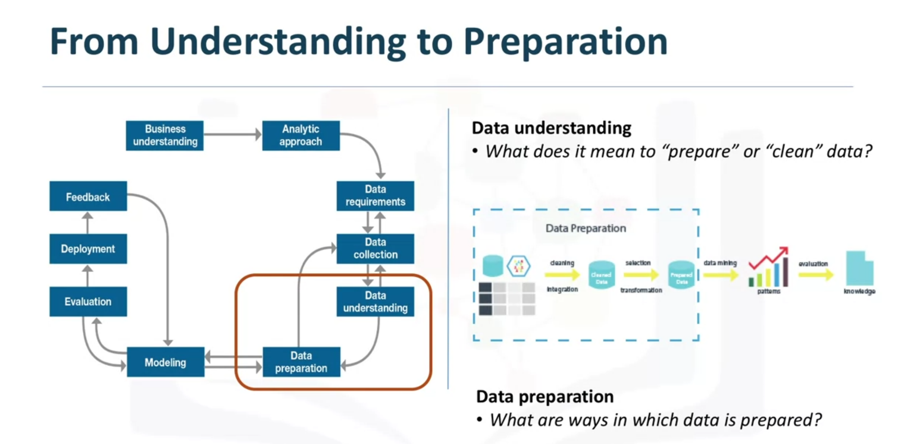

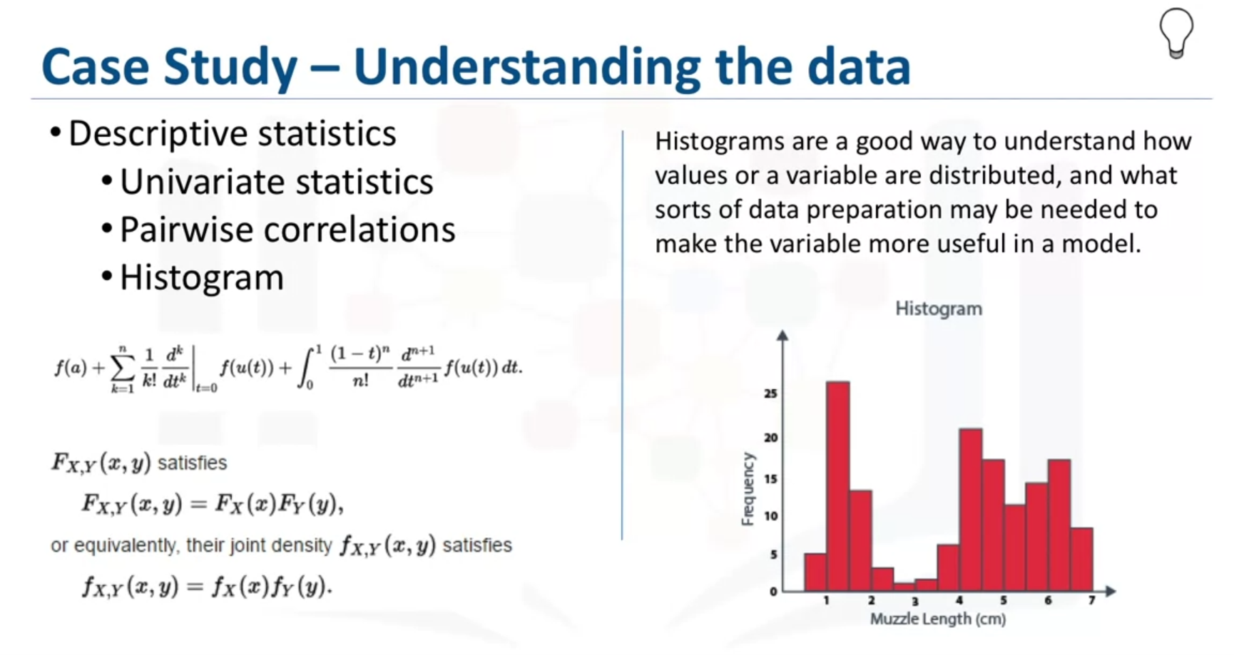

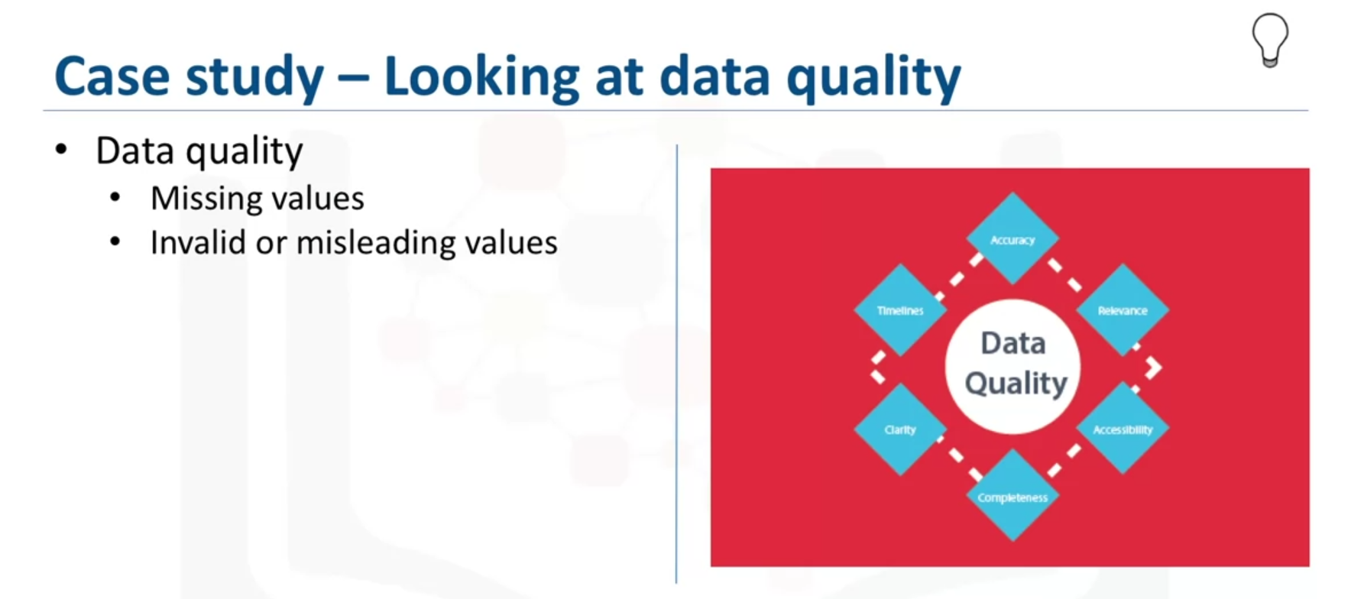

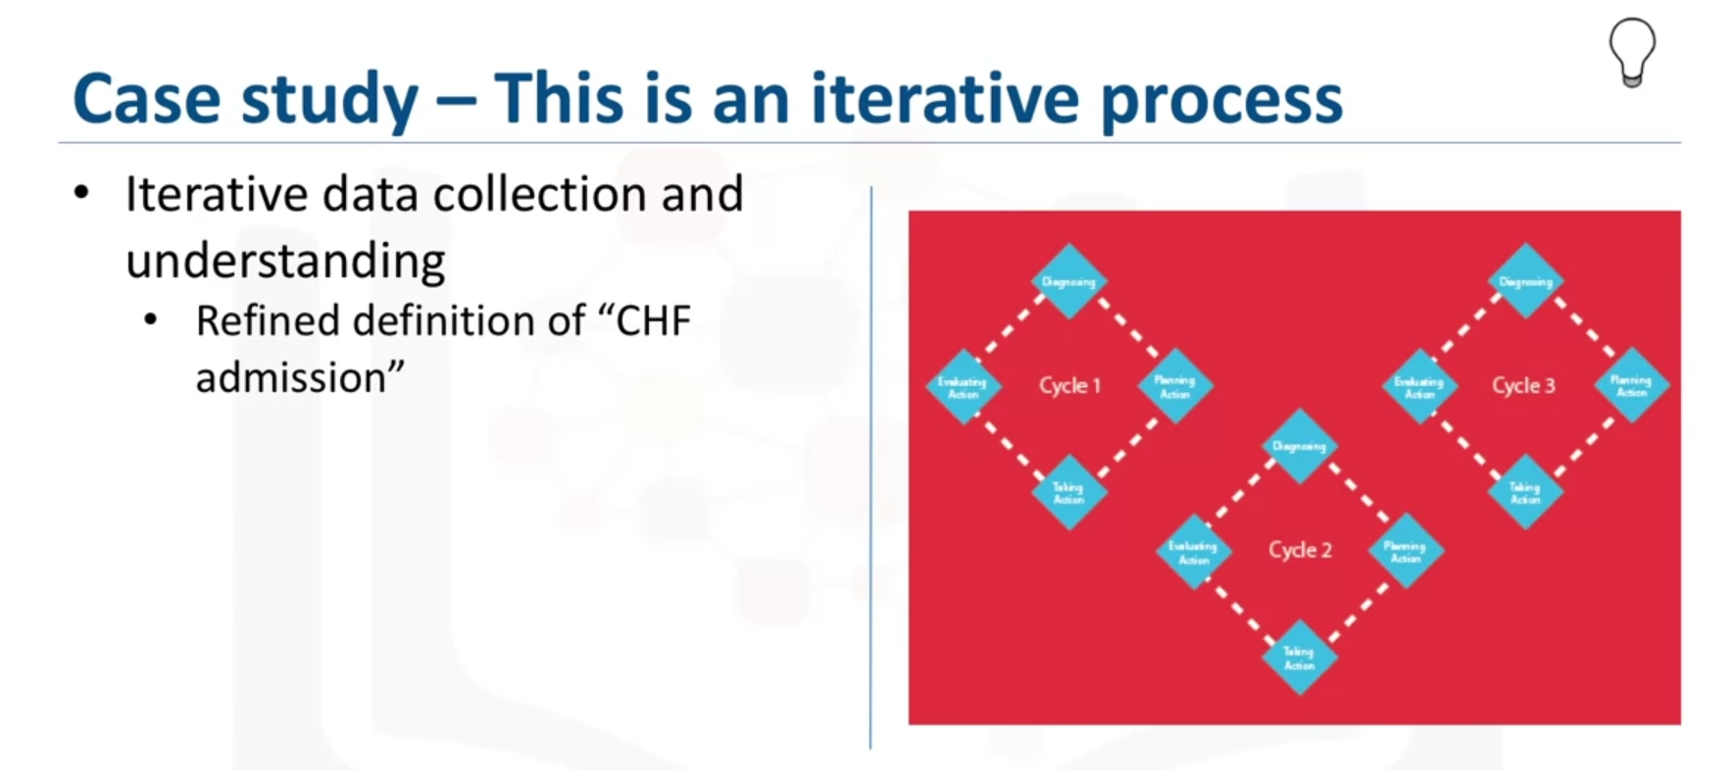

Data preparation is the most time-consuming phase of a data science project, typically taking seventy percent and even up to even ninety percent of the overall project time. Automating this process could decrease this percentage to 50%.

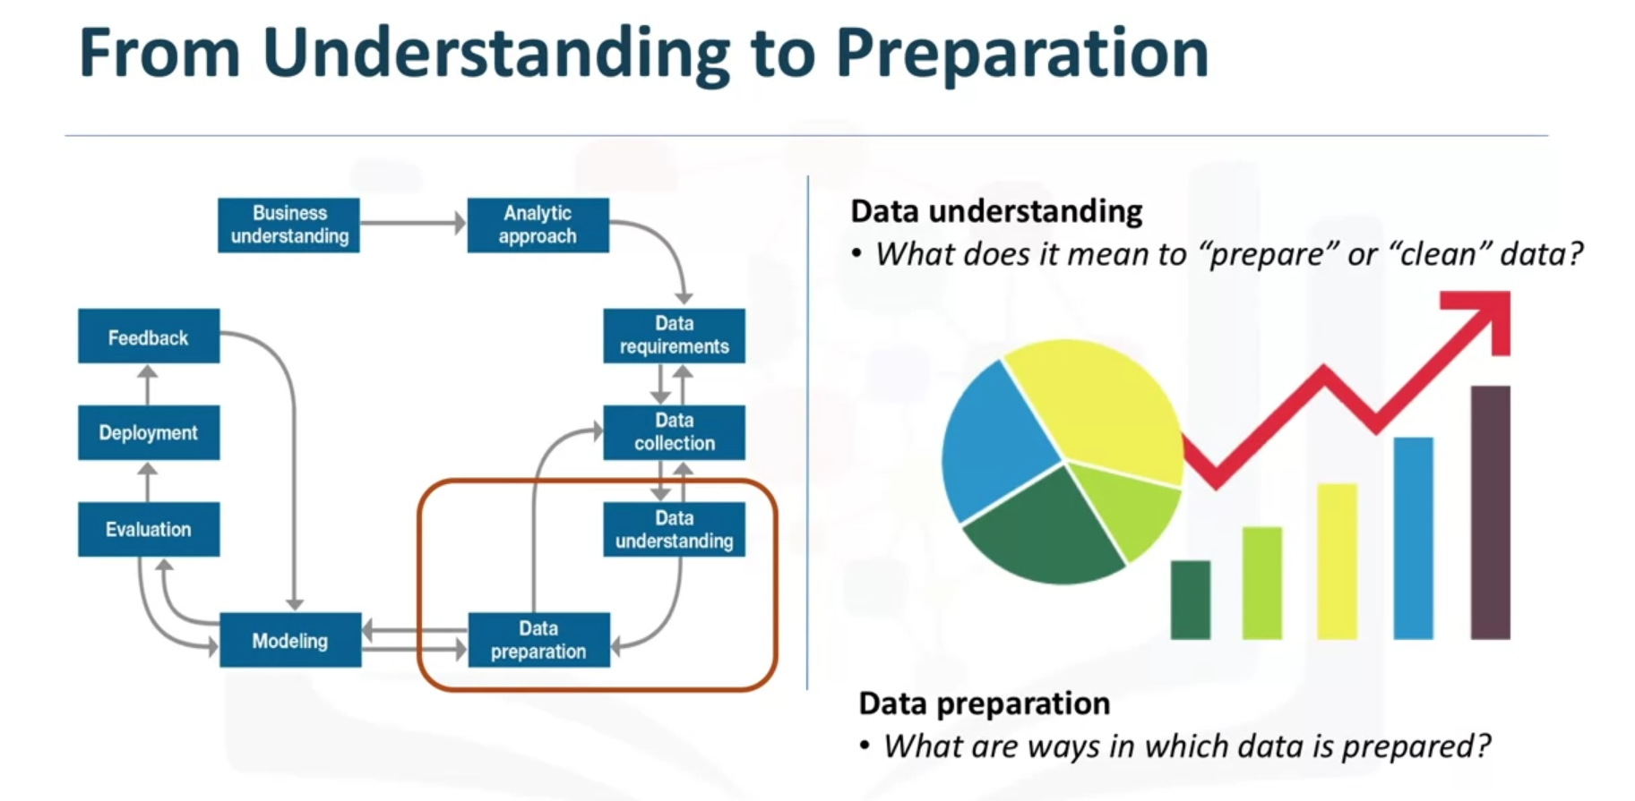

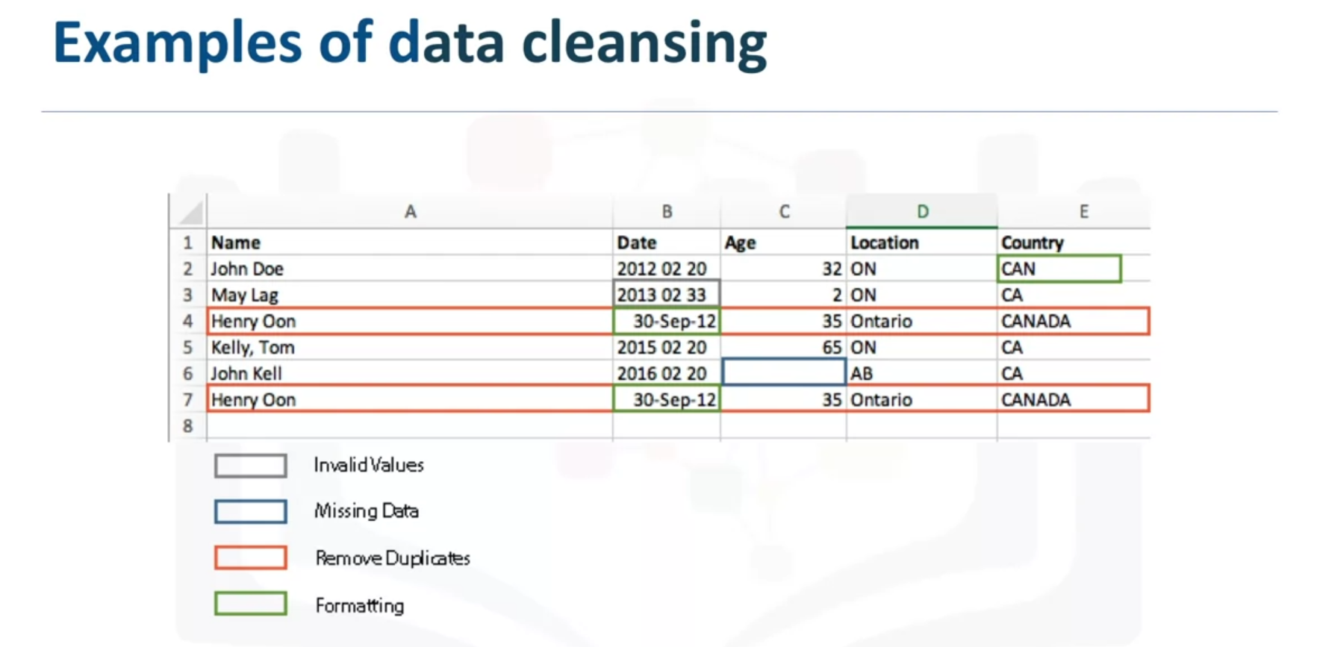

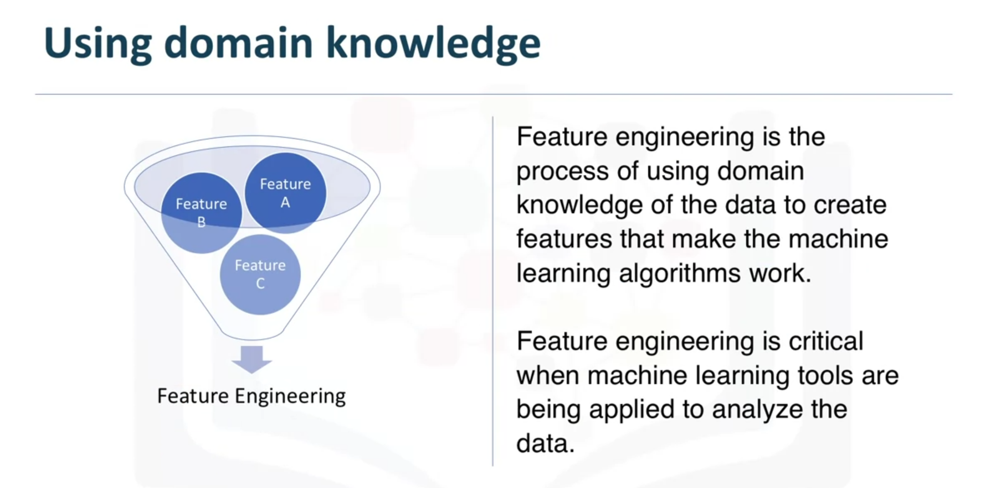

Please note that the phrase "literary review" in the next video: Data Preparation - Case Study, is supposed to be "literature review".

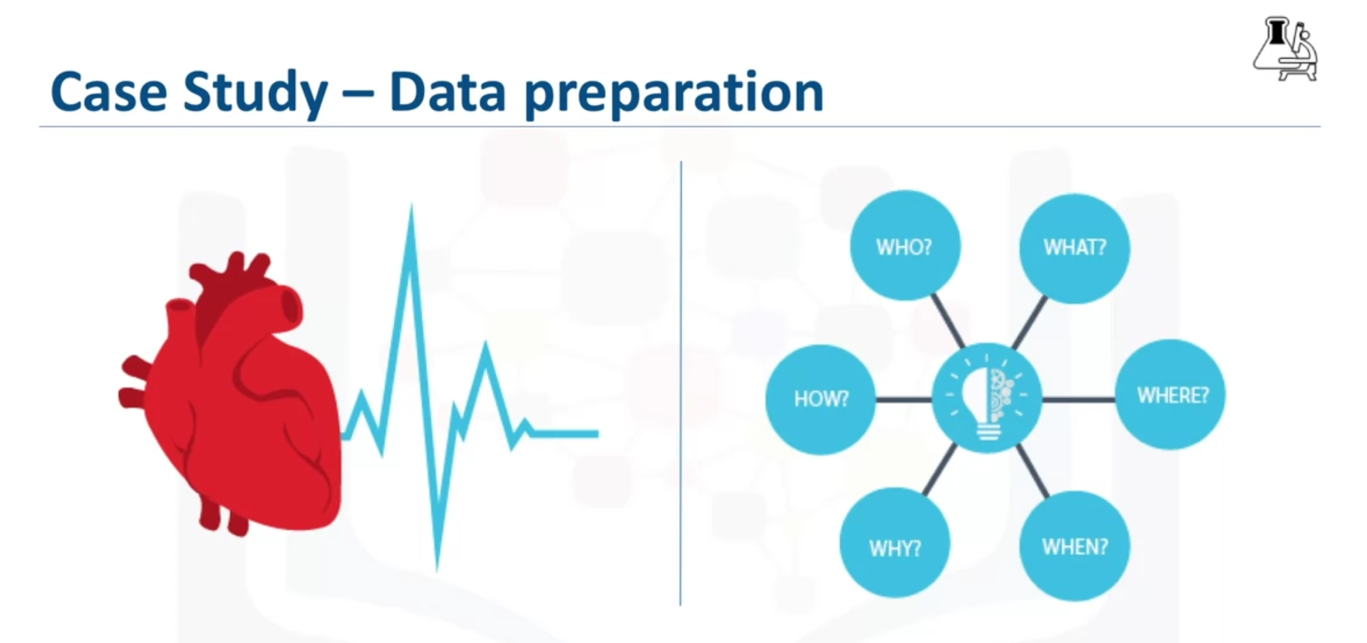

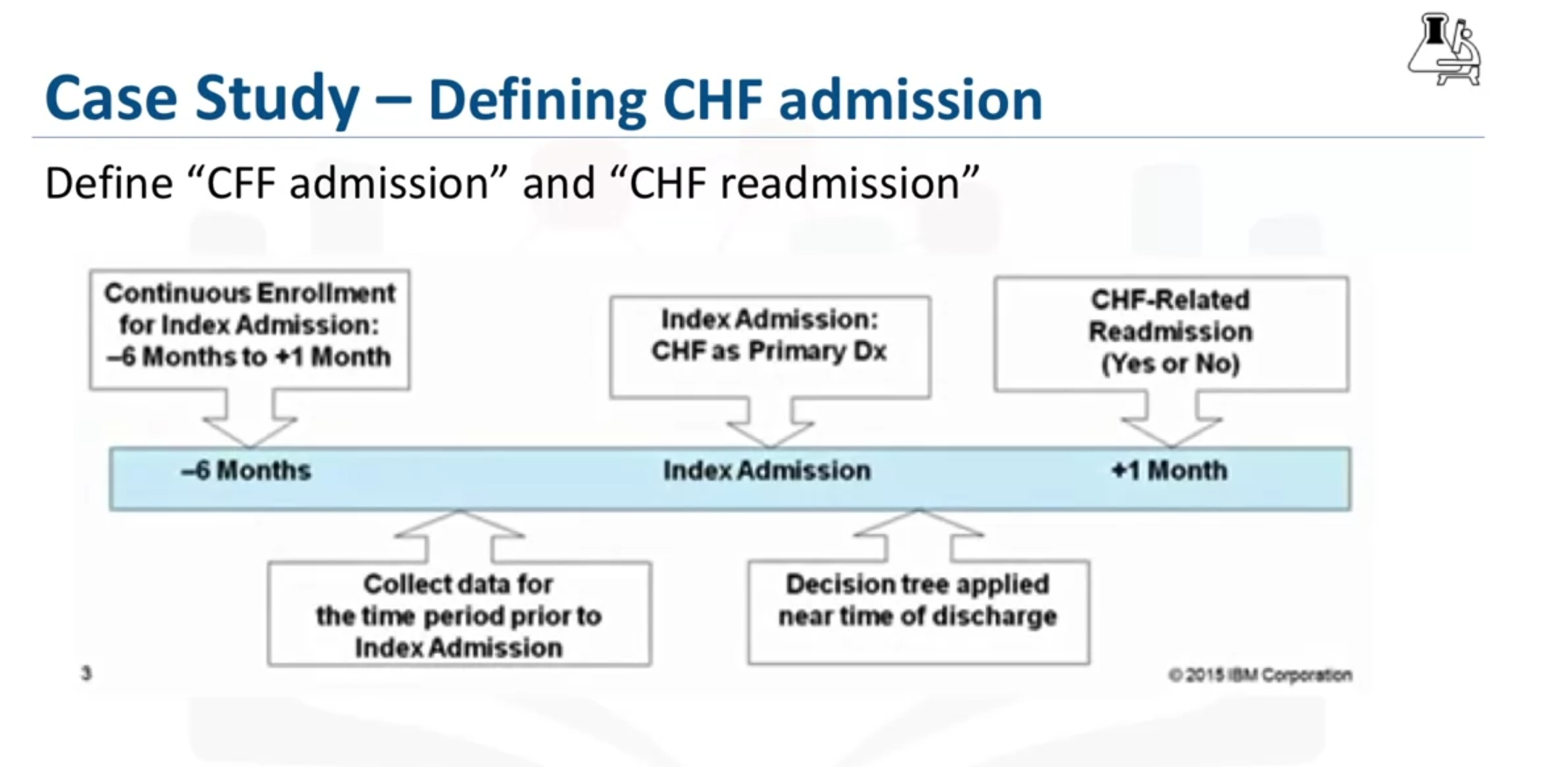

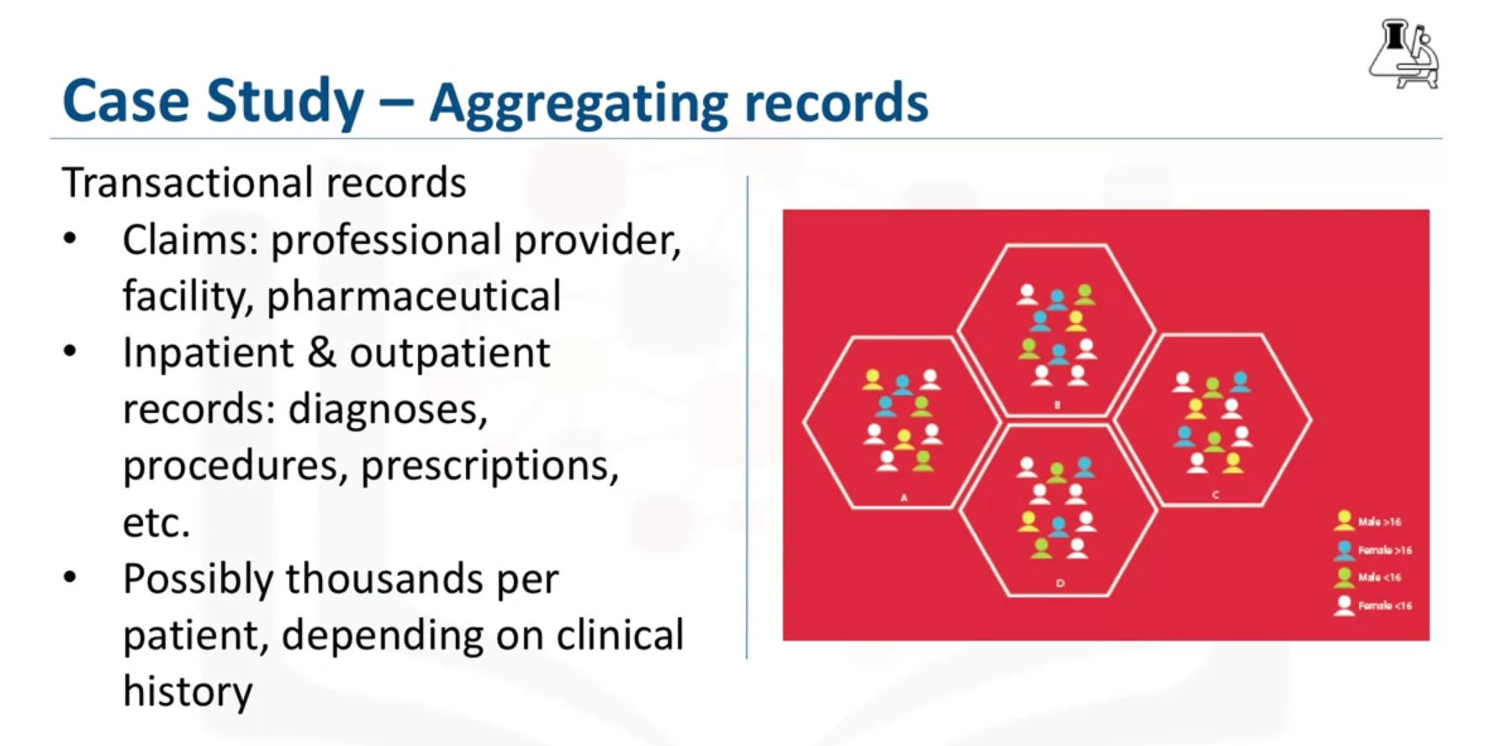

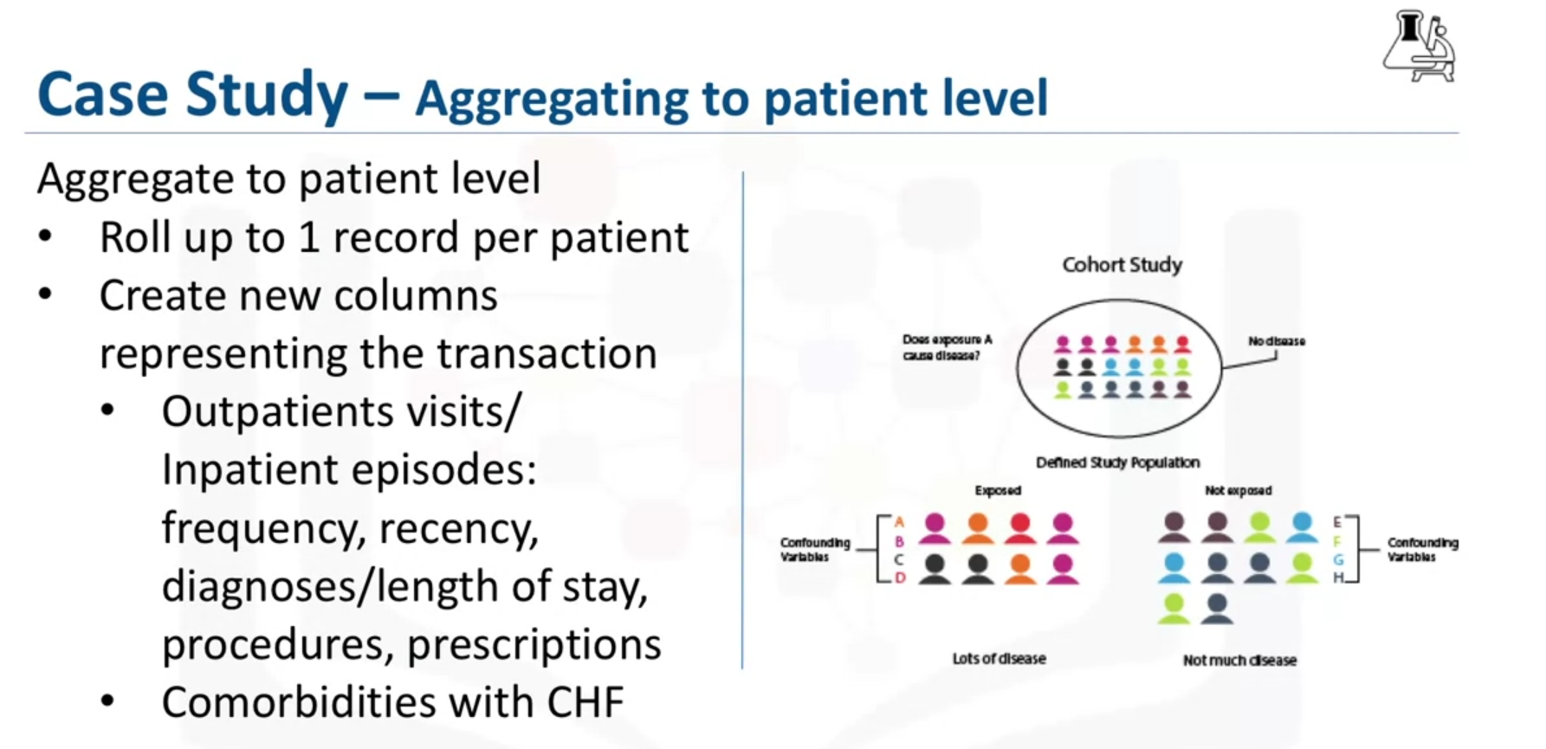

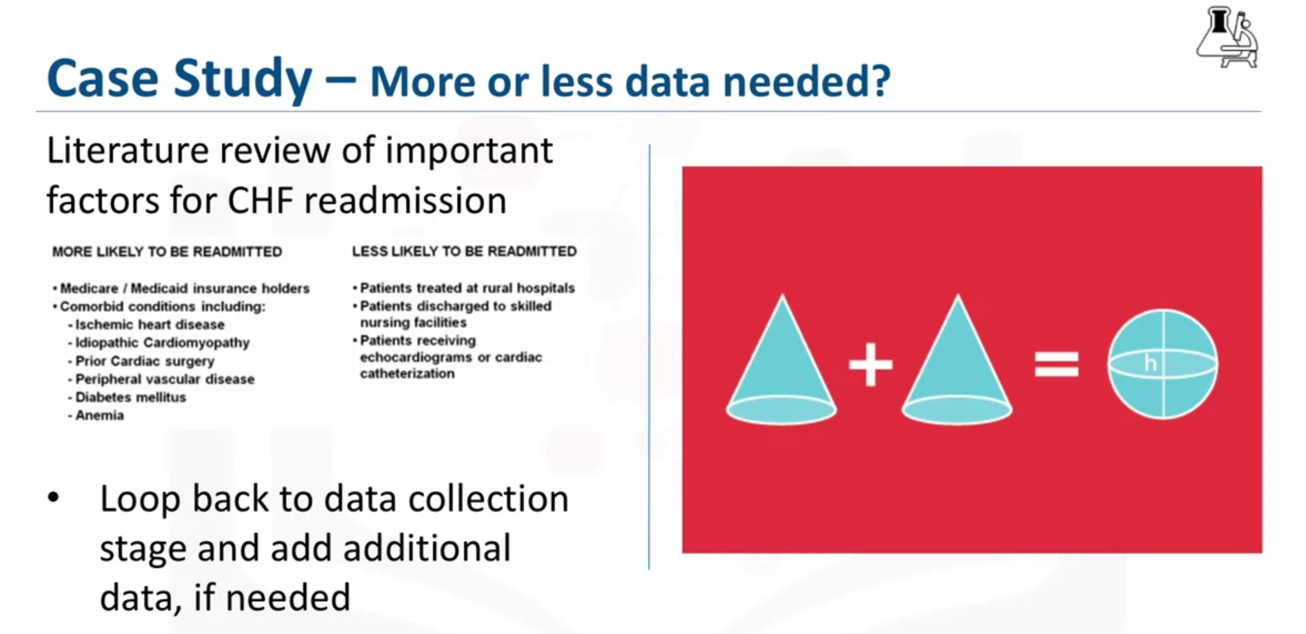

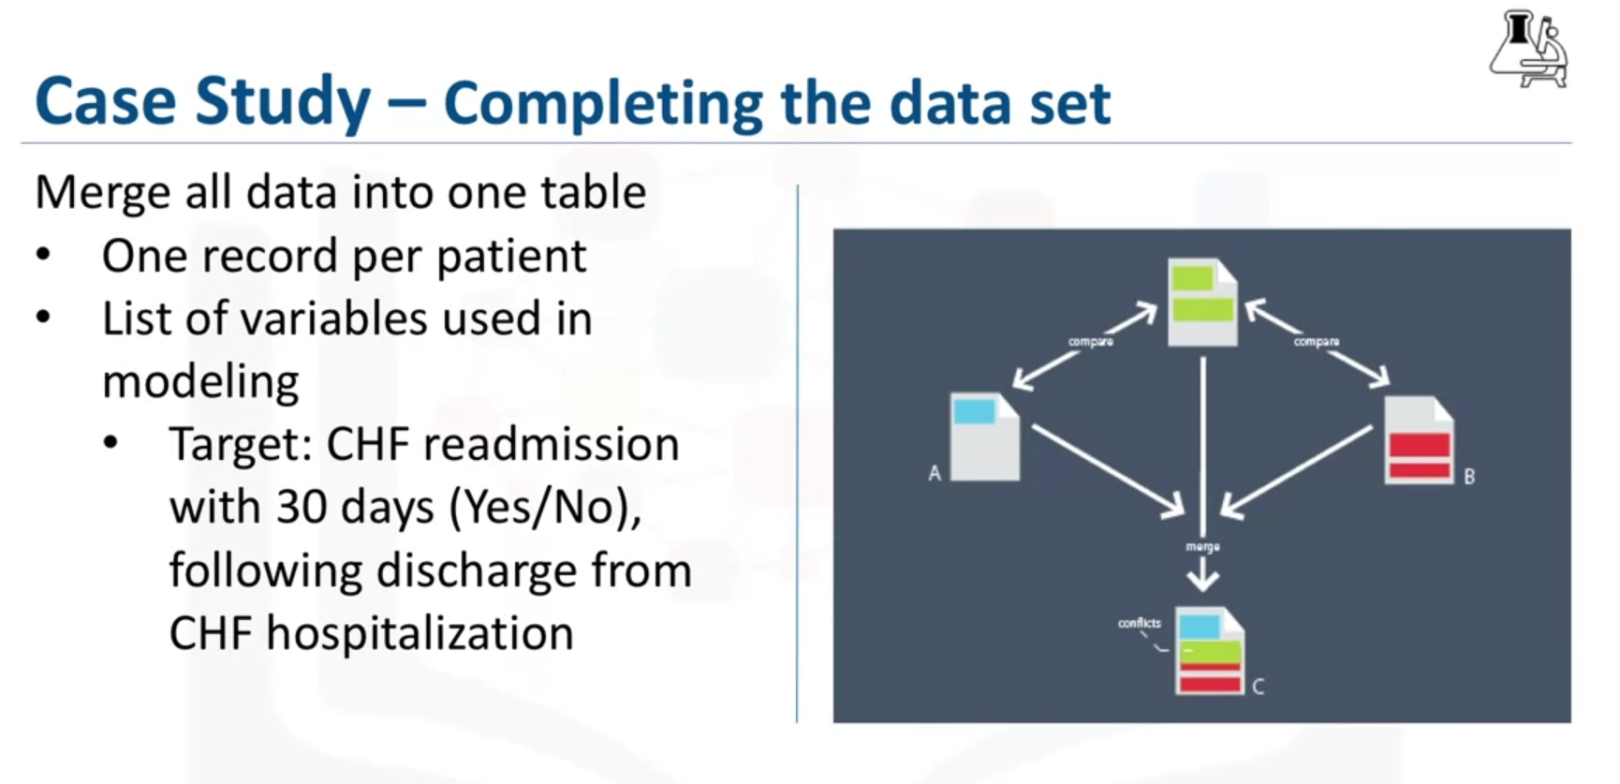

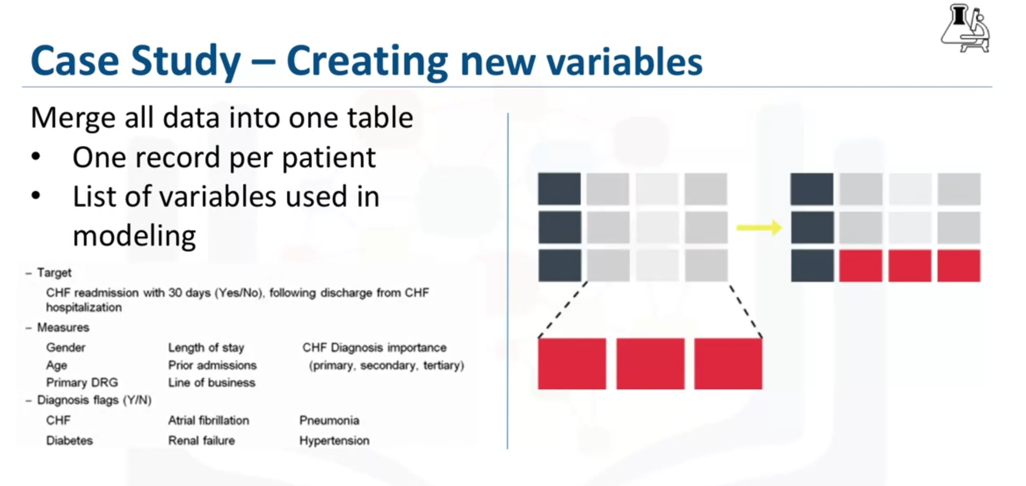

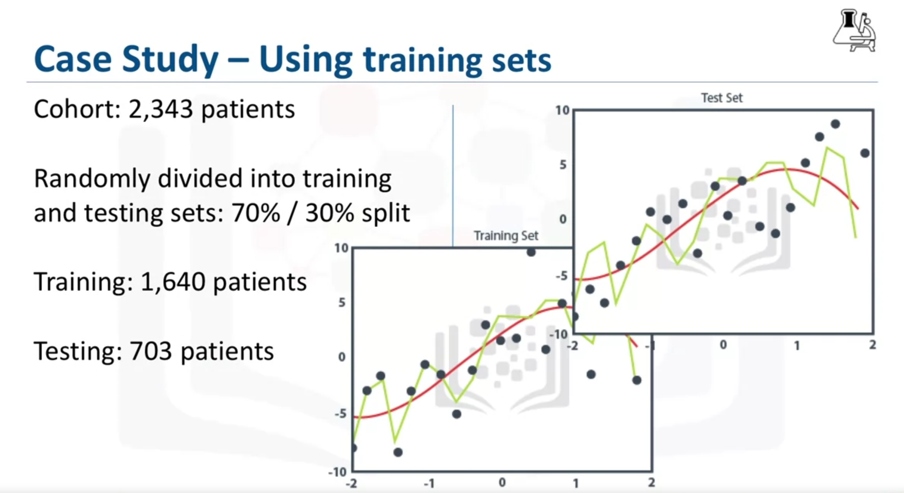

In this lesson, you have learned:

* The importance of descriptive statistics.
* How to manage missing, invalid, or misleading data.
* The need to clean data and sometimes transform it.
* The consequences of bad data for the model.
* Data understanding is iterative; you learn more about your data the more you study it.

**From Modeling to Evaluation**